Pulitzer Center Campus Consortium International Reporting
Student Fellowship Application
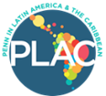 |  | 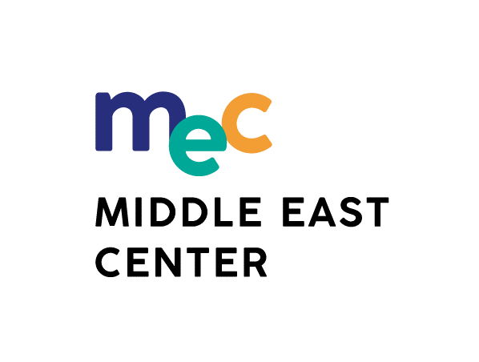
Thank you for your interest in the Pulitzer Center Campus Consortium International Reporting Student Fellowship. Full-time Penn students in all undergraduate and Masters-level degree programs returning to Penn for full-time study in the fall of 2022 are eligible. Please complete this 3-page application form electronically, save as a .pdf, and submit it, along with your resume/CV and work samples, via email, as follows:
- By deadline: February 1, 2022: for the Middle East / North Africa region reporting: mec-info@sas.upenn.edu
- By deadline: February 1, 2022: for the Latin American / Caribbean region reporting: plac@upenn.edu
- With subject line: either “MEC Pulitzer” or “PLAC Pulitzer” : [your last name]” E.g. if your name were John Smith, and you were proposing a project in Jordan or Egypt, your subject line would be “MEC Pulitzer: Smith”

Reporting Region  (type“X” in box left of region) |  | MEC) Middle East /  North Africa |  |  |  |  |  | (PLAC) Latin America / Caribbean
Name | Last |  |  |  |  | First
Email Address
(one you check frequently)
Mailing Address
(street/apt; city, state; zip)
Penn Home School
(e.g. SAS / SON / SEAS)
Degree Program & Major(s) / Minor(s) | Degree Program |  |  | Major(s) |  |  |  | Minor(s)
Expected Graduation Date | Semester |  |  |  |  |  | Year
Anticipated country(ies) for travel / where reporting will be focused
Describe prior experience you have in traveling independently abroad or in your home country
Is the travel/ reporting country your home country? | Yes |  | No |  | Note: fellowship cannot be used for home country reporting

About Your Proposed Reporting Project
General Topic
Specific Angle on Topic
In 250 words or less, in space below, provide a description of your project focused on significance of the story and feasibility of reporting on the topic and angle, including sources, logistics, health, & security issues
Note below your connections to the topic/place you wish to report on by providing the following information
Your skill, if any, in dominant language of country you will visit (specify language and skill level)
Describe your knowledge of the culture of proposed country
Note any prior travel to that country and/or related knowledge
List/describe connections (direct or indirect) you have to any individuals or organizations in the proposed country who may be of help in your reporting project
List 2 references, academic or professional; if possible, include at least one from a faculty member who may have a direct interest or serve as project mentor
 | Reference #1 |  | Reference #2
Full Name / Degrees
Title / Organization
Phone #
Email Address
Note any plausible distribution avenues other than the Pulitzer Center that you are considering for this reporting

Submitting Your Application and Important Conditions

Include as attachments with this application your resume/CV and 2-3 recent samples of your work; e.g. blog entry, website, photo journalism, academic writing (5 pages or less). Video samples are welcome and can be sent by mail in DVD format to the address below or via online hyperlinks. See first page of this application for instructions for required email submission and due date.
List items you cannot attach via email that you will mail in (by due date) Note mailing address below
Address ONLY for items that cannot be sent by email:
Pulitzer Center on Crisis Reporting
Campus Consortium Reporting Fellowship Application
1779 Massachusetts Avenue NW, Suite 615
Washington, D.C. 20036

IMPORTANT NOTE: An electronic version of this application MUST be e-mailed by indicated due dates regardless of any materials you may need to send via “snail” mail. Mailed items must also arrive by due dates.
CONDITIONS: If you are awarded a Pulitzer International Reporting Student Fellowship, your project will have set deliverables (e.g. three blog posts, a narrative slideshow and a longer piece) agreed to by you and the Pulitzer Center and due by the end of August, 2022. Your work will be published on the Pulitzer Center site and possibly other outlets. You will also be expected to participate in outreach efforts for South Asia Center (SAC), Penn in Latin America and the Caribbean (PLAC) and Middle East Center (MEC) upon return to campus. This Fellowship, if travel is involved, includes a $3,500 award ($3,000 from Penn Global (GRIP)/ PLAC and $500 from the Pulitzer Center). Successful applicants must meet Penn Global and Pulitzer Center eligibility requirements. This includes a commitment to spend a minimum of eight weeks abroad engaged in this Fellowship/ Internship. Upon award announcement, fellows will receive instructions on how to obtain the Penn Global/PLAC grant of $3,000. Once deliverables have been satisfactorily completed, the Pulitzer Center will provide a final $500 award.
If you have any questions or difficulty regarding submitting your application, please email
mec-info@sas.upenn.edu (for Middle East/North Africa) or plac@upenn.edu (for Latin America / Caribbean)
For general questions about the Pulitzer Center, email reportingfellows@pulitzercenter.org

